Please do not hesitate to contact us if you have any questions. Thank you,

**Mrs James**

**Snack**

Please could children bring fruit, yoghurt, or vegetables for their playtime snack.

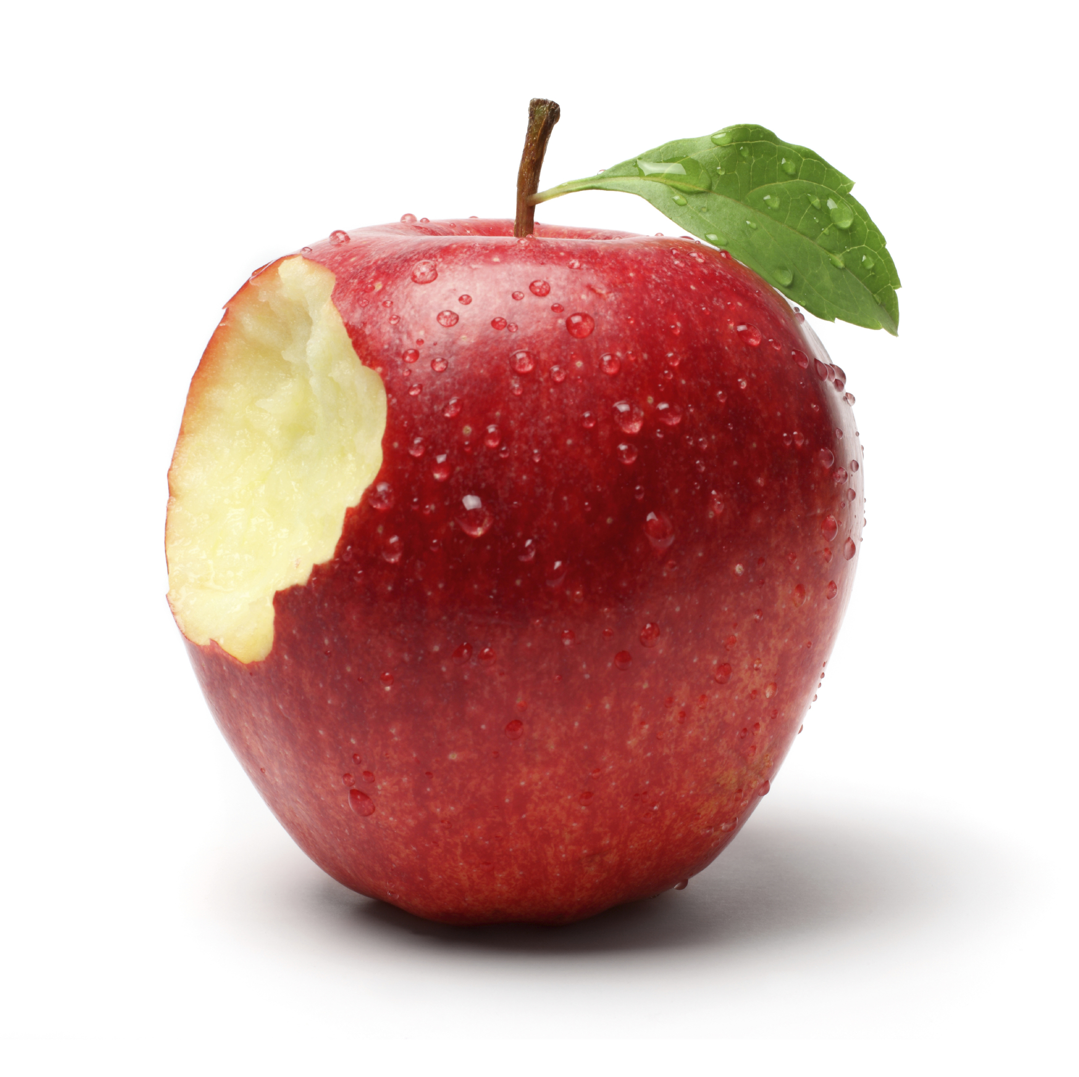

**Wellbeing Activities**

* **Daily Mindfulness sessions**
* **Empathy Lab Initiative**
* **Rights of the Child**

General Information

* PE will be every **Tuesday.**
* Please send in Reading book bags daily.
* Homework will be posted on Teams every Friday.
* Spellings will be given out/tested every **Friday** and will be posted on Teams.



Dear Parents, Guardians and pupils, we hope that you had a relaxing Summer break and are now ready for the new Autumn Term.

**Good To Be Green**

At the end of every half term, we celebrate the children’s good behaviour with a fun activity!

### This Term’s Topic:

**What happened to the Celts?**

This term, children will visit St Fagan’s to find out what life was like for the Celts in the Iron Age. Back in the classroom, they’ll find out more about Celtic family life, childhood, leadership, the Druids and the Otherworld. They’ll act as Celts, dressing up in classic Iron Age fashions and modelling and decorating sacrificial gifts for the Druid gods out of clay. Then it’s back to the future where they’ll act as archaeologists, tracking down Iron Age artefacts and discovering the mysteries of bog bodies. At the end of the project, they’ll reflect on what they have learned about the Celts and create an informative display.

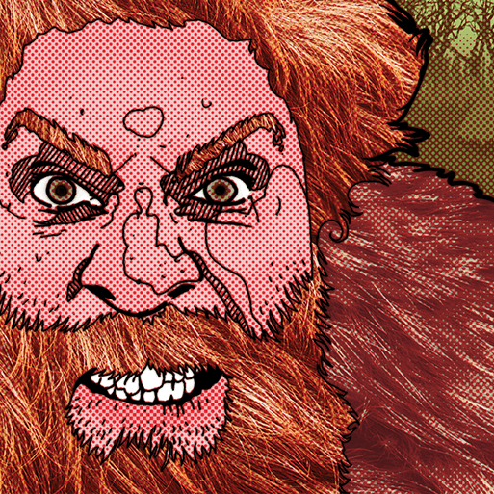

If you have any information/photographs/books on this topic, please feel free to share!

Link to information regarding the new Curriculum for Wales:

<https://hwb.gov.wales/curriculum-for-wales>

**Year 3/4 Autumn Term 2024**