 Autumn Newsletter
26/09/2025
Dear Parents and Carers,
Fresh Term
The Autumn term is now in full flow, and I would like to thank our wonderful parents, carers and friends of Parc Lewis, for your continued support and encouragement with our new morning routine, especially during what turned out to be the wettest September in recent memory! The sun has been shining on us over the last week, and your patience, positivity, and feedback have made a real difference.
Swimming
Our children in Years 3-6 have made a real splash attending their 3-week block of swimming lessons on a Monday, Tuesday and Wednesday. After just 6 days of this routine, the children have already shown maturity and have increased their confidence and independence to dress and undress, listen and learn in a new learning environment. Their personal growth is wonderful to see.
Home School Partnership
Mrs Morgan has been busy organising a range of excellent Family Engagement activities. Once again, we have embraced the PIPYN workshops for our Foundation age children and parents. Our Nursery children have also had lots of fun in ‘Talk and Play’ Tiny talkers Group from the RCT ‘Talk-and-Play’ team being held at the school.
Authentic Curriculum Learning Experiences
Miss Jones and Year 3 enjoyed a fabulous afternoon meeting the hidden heroes of our community. A big thank you to everyone for your help in enriching the learning experiences for our pupils.
Years 5 & 6 have been busy looking at the local area and visiting the Foodbank to enrich their topic learning back in the classroom. These authentic experiences are a valuable part of our school curriculum this year.

School Communications and Information sharing
Communication issues was a priority area identified in the last Parent Questionnaire. Here is an outline of our current communication tools and their uses. We are working with the Local Authority this year to simplify school communications.
Facebook  was recorded as the tool for communication that was most preferable for parents. This is a closed whole school group and parents/Carers need to request to join. Facebook is used for communicating school activities, local area linked events for pupils and families and celebration of pupil learning.
Microsoft Parc Lewis Class Teams Channels  Since Covid, Parc Lewis has used Teams for communicating specific class-based information and this will always come direct from the class teacher in the class Teams channel. This is a safe closed space for the class only.

Mrs Gogherty, Digital Champion, is available Wednesday’s, after school 3.20-3.40, to assist with any logging into HWB  (Teams) pupil account issues. Please make use of this opportunity so that you don’t miss out on valuable information and communications from your child’s teacher.

Website  This is a public, open space where mandatory educational documents are shared. Some general sharing of class information is shared at different times whilst ensuring we adhere to GDPR. Please check into the school website regularly where you can find downloadable newsletters and see our lates news.
The text messaging Service, Teachers2Parents  is used to convey very immediate and important specific school information and signpost parents/Carers to letters/ newsletters stored on the website for more detail where needed.

Term time dates 2025-2026 | FROM | TO
Autumn 2025 | Monday, September 1 2025 | Friday, October 24 2025
Half Term | Monday, October 27 2025 | Friday, October 31 2025
Autumn 2025 | Monday, November 3 2025 | Friday, December 19 2025
Christmas Holidays | Monday, December 22 2025 | Friday, January 2 2026
Spring 2026 | Monday, January 5 2026 | Friday, February 13 2026
Half Term | Monday, February 16 2026 | Friday, February 20 2026
Spring 2026 | Monday, February 23 2026 | Friday, March 27 2026
Easter Holidays | Monday, March 30 2026 | Friday, April 10 2026
Summer 2026 | Monday, April 13 2026 | Friday, May 22 2026
Half Term | Monday, May 25 2026 | Friday, May 29 2026
Summer 2026 | Monday, June 1 2026 | Monday, July 20 2026
We look forward to working in partnership with you over the coming academic year.
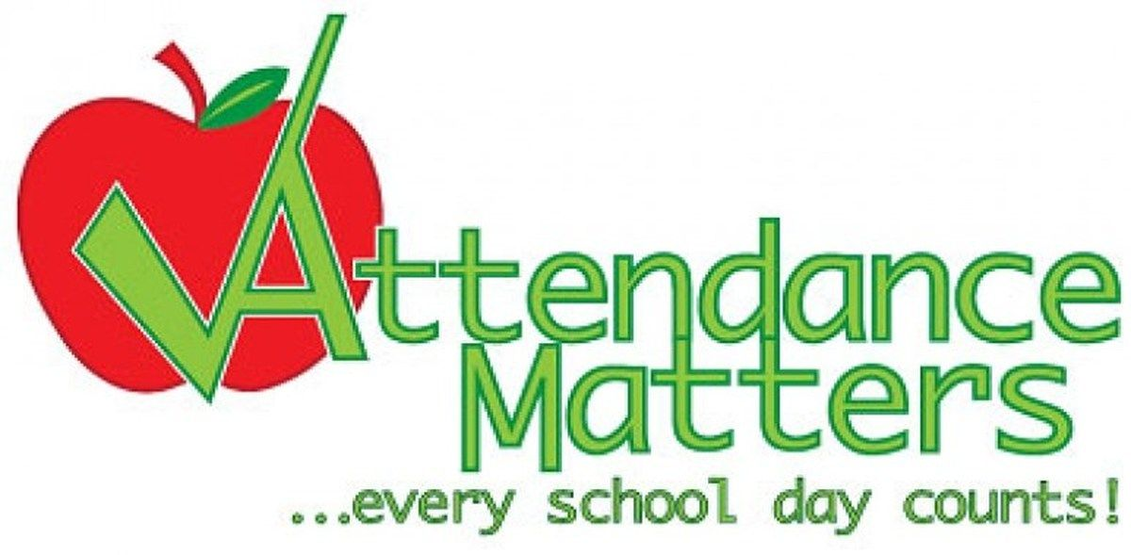 Doors/Gates are open from 8.45am & 8.55am,
in order to ensure that all pupils are seated for classes time to begin promptly.

- In order to report your child/ren absent from School, please use the facility on our phone line by pressing Option 1 immediately to leave the information required. As you can appreciate the phone is very busy, and as we have more than one incoming line it might seem we are not answering your calls. Voicemails left are checked frequently throughout the school day.

- Where possible please avoid taking your child out during school hours to attend medical appointment, however we understand that there are emergencies which require appointments on the day, and certain appointments are pre-booked which cannot be re-arranged. School requires a copy of appointments, in order to authorise your child/ren attendance.

- Attendance is an area which we will continue to monitor. It is vital for children to be in school and on time so they have the greatest opportunity to learn and be with their friends.
Fixed Penalty Notices have been reintroduced and the AWS service will continue to visit homes where children are absent and school has not received an explanation.
Thank you for your continued cooperation in these important areas.
Mrs Hughes

