Curriculum Policy
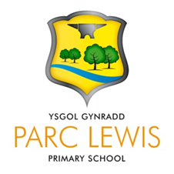

Parclewis Primary School
Ysgol Gynradd Parclewis

Policy Leader :
Head teacher : Mrs C Hughes
Chair of Governors : Mr A Minton

Policy applies to Academic Year 2024 -25
Signed HT: Date:
Signed CoG Date:

This policy is a: | School Plan using LA & WG guidelines
This policy is a: | Statutory Policy
Policy / Document Leader: | Miss L Jones
Link Governor: | Martin Davis
Key Personnel in Policy: | Headteacher,
Published / located: | / School Administration Office
Aims of Policy:

- To outline the policy and provision for the curriculum at the school.

Review date | May 2025
Next review date | October 2025
Reviewed by | Policy committee

CURRICULUM FOR LEARNING

Policy and Practice at:

Parclewis Primary School

Curriculum for Learning Policy
A Guide to our “Purposeful, Authentic & Relevant Curriculum”
(Curriculum for Wales CfW) We are a: “A Rights Respecting School!”

Our Mission Statement
“One family, shining brightly”
“Un teulu yn disgleirio’n llachar”

Our Vision Statement
For every learner to flourish and excel within our inclusive, respectful learning environment and ethos. Reaching their full potential of skills and knowledge, learners become active members of the school, community, Wales and beyond, working together to help each-other succeed.

Values

- Inclusive (Everyone included)
- Kindness (empathy, compassion and consideration for others)
- Collaboration (Working together)
- Ambitious (Aiming for excellence)

School Aims

- To nurture healthy, confident and happy pupils who have a strong sense of cynefin.
- To encourage pupils to be ambitious and capable learners who embrace challenges, are resilient and transfer their learning into the world beyond the classroom.
- To create enterprising, creative and independent learners who have the tools to choose to always give their best efforts in all they do.
- To engender ethically, informed citizens who are respectful, show empathy and embrace the rights and needs of others.
- To awaken a sense of wonder, fire the imagination and inspire learners to grow in knowledge, understanding and wisdom.
- We aim to become a Community Focused School, where families are made to feel welcomed, listened to and valued. Their needs, and those of their children, are understood and catered for and where they are encouraged to play an active role in their child’s learning.
- To have high expectations as a learning community in which the ethos of effort, progress and success is jointly celebrated.
- To ensure equity of provision to ensure our whole school community can thrive.

POLICIES TO BE READ IN CONJUNCTION WITH THIS DOCUMENT:

- Planning Policy (CfW)

- Assessment Policy (CfW)

- Assessment for Learning Continuum (CfW)

- Feedback for Learning Policy

- Additional Learning Needs Policy (CfW)

WELCOME TO OUR SCHOOL

The United Nations Convention on the Rights of the Child (UNCRC) is at the heart of our school’s planning, policies, practice and ethos. As a rights-respecting school we not only teach about children’s rights but also model rights and respect in all relationships. Our belief in “restorative approaches” ensures that every child is listened to.
We believe that every member of the school community is a learner which includes pupils, staff and parents. Together we develop as a learning organisation, using information from research, other schools, businesses and the real world to build a culture for improvement.

Across all Areas of Learning and Experience (AoLEs), the application of numeracy, literacy and digital competence is robustly planned for. Teachers are expected to plan and deliver learning objectives pitched appropriately to the learners needs. Lessons have success criteria (which also include numeracy, literacy and/or digital competency) to ensure the learners are aware of the particular skills they are looking to develop within that lesson. In addition to literacy, numeracy and digital competence, teachers plan for incidental Welsh and opportunities to address relationships and sexuality education in line with the new Curriculum for Wales.
There is a whole school and cluster approach to well-being enabling pupils to understand their own and others’ emotions. This is in line with the Health and Well-Being AoLE, and is integrated throughout the school day, and throughout the curriculum itself.

Every opportunity is used to promote the ethos of “Every child can be the best they can be!”

CURRICULUM FOR WALES

Curriculum for Wales 2022 organises learning around six areas of learning and experience. Each of the areas of learning and experience has been designed to support learners to realise the four purposes of the curriculum. They are intended to promote collaboration and cross-disciplinary school-level curriculum development and design

All teachers plan for the cross-curricular responsibilities of literacy, numeracy and digital competence to support almost all learning. These are essential for learners to be able to participate successfully and confidently in the modern world
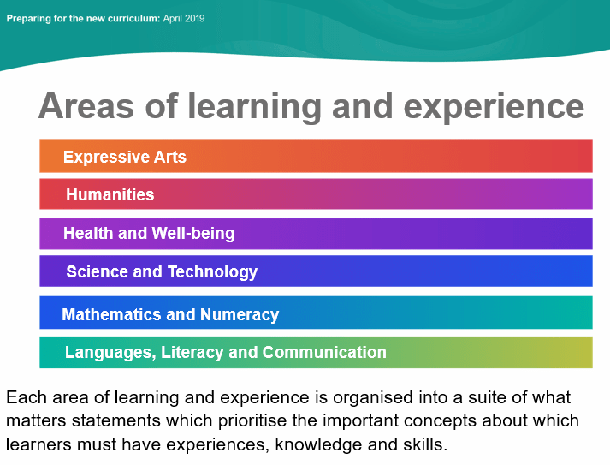
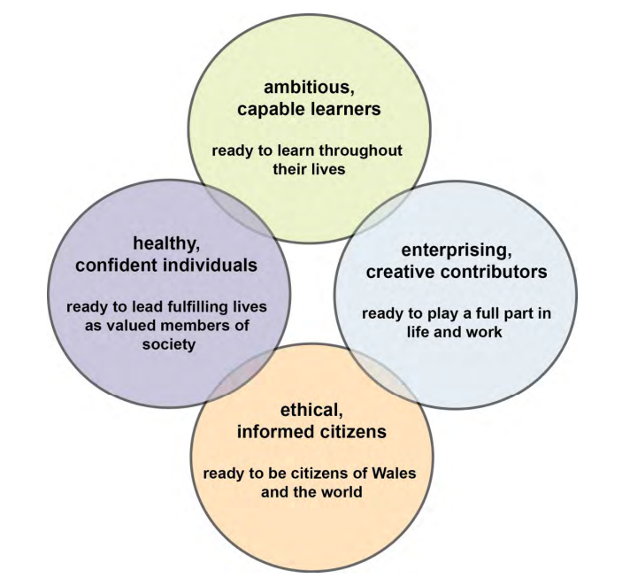
The six areas of learning and experience
The four core purposes

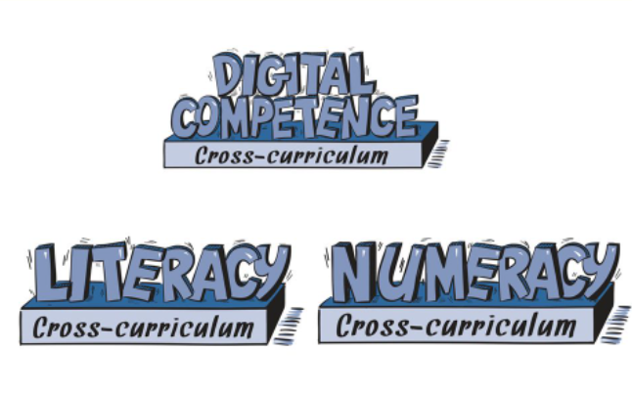
Cross-curricular skills

The 12 Pedagogical principles

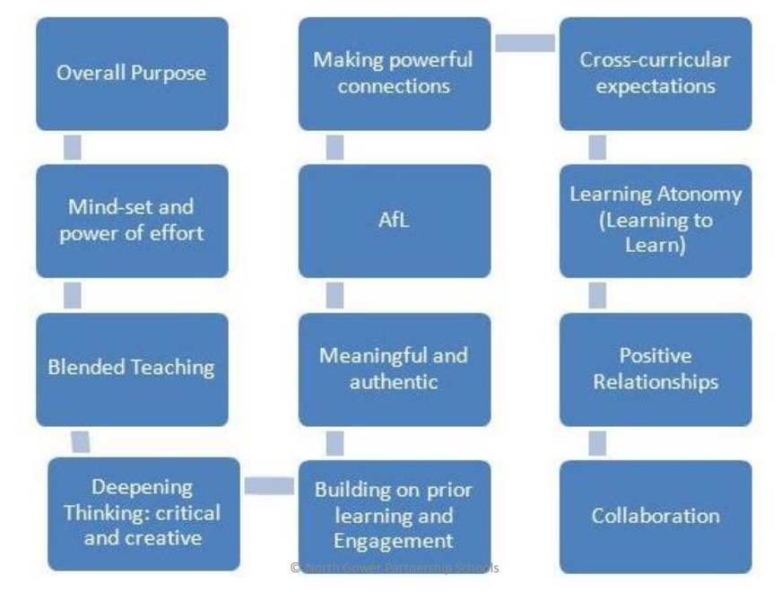

Children's Rights

Children and young people have 42 rights under the United Nations Convention on the Rights of the Child (UNCRC). These 42 rights give children and young people what they need to grow up happily, healthily and safely. In 2011 Wales became the first country in the UK to make the UNCRC part of its domestic law.

The principles of a Children’s Rights Approach are:

- Embedding children’s rights - at Parclewis this means that all policies are underpinned by the UNCRC, and all our community know and understand about children's rights.

- Equality and Non-discrimination - at Parclewis we make sure that every child aspires to be the best they can be. This is encapsulated in our school Vision and Mission statements.

- Empowering children - At Parclewis pupils are actively involved in planning their curriculum.

- Participation - At Parclewis adults and pupils share the decision making and together drive policy and change.

- Accountability - Parclewis Primary School is held to account for how pupils experience their rights by the governing body and pupil voice groups

EQUAL OPPORTUNITIES
At Parclewis Primary School, we are committed to ensuring equity of education and opportunity for all pupils, staff, parents and carers receiving services from the school, irrespective of disability, race, gender, age, sexual orientation, religion or belief, gender reassignment, pregnancy & maternity, marriage and civil partnership.

We aim to develop a culture of inclusion and diversity in which all those connected to the school feel proud of their identity and able to participate fully in school life

POSITIVE RELATIONSHIPS
Parclewis Primary School has a very positive behaviour culture. We are very proud of the excellent behaviour of our learners who are frequently praised by visitors and when visiting other places for their beautiful manners and general behaviour. Good behaviour is a necessary condition for effective teaching and learning to take place.
The most meaningful and positive form of discipline is self-discipline. We work hard at Parclewis School to instil this in our learners.
The response to misbehaviour is always positive and will depend on the nature of the misdemeanour, and the age and maturity of the pupil. We deal with any misbehaviour using a restorative practice approach. This enables the pupil to explain their thoughts and reasons for their behaviour choice through 3 questions.
- What happened?

- How were you feeling?

- What could we do next time?

This enables pupils to be listened to and also makes them aware of the effect that their actions have on others.

MENTAL HEALTH & WELL-BEING
Links to Children's Rights: Learning within the Health and Well-being area of learning supports children to understand their rights and the rights of others (Articles 2 and 42 of UNCRC). It also supports children to experience their rights to be safe and protected from harm (Articles 19, 33, 34, 36) and also promotes the right of children to relax and play (Article 31) and to have healthy food and clean water (Article 24).

In Parclewis we teach and develop mental health through:-

Explicit teaching of the science self regulation

Flexible timetables to meet pupils’ needs

Effective links with outside agencies

Daily Check-ins

Restorative Practice

Self regulation areas and resources
We encourage our learners to develop self-regulation, and to understand the “how and why” of their emotions in order for them to develop strategies to best help and support them. Each term the pupils learn about their amygdala and how this effects how we behave when we are angry, stressed or anxious. Children will regularly self-assess themselves to identify where they are in terms of their feelings, and what they can do to help move them into a more mentally healthy zone.

ADDITIONAL LEARNING NEEDS (ALN)
At Parclewis Primary School we recognise that all pupils come to school at different stages of development and with different needs. Whilst many factors contribute to the range of difficulties experienced by some children, we believe that much can be done to overcome them by parents, teachers and pupils working together
Pupils who meet our criteria for having ALN will be supported by class teachers, teaching assistants other adults and their learning environment

The ALN aims of the school:
- To meet the needs of all pupils through excellent teaching strategies, classroom organisation and differentiation.

- To have a whole school Universal Provision that addresses the needs of all pupils.

- To ensure that all pupils have access to a broad and balanced curriculum.

- To ensure that early identification of a pupil’s needs is made.

- To ensure that ALN pupils take as full a part as possible in all school activities.

- To use a Person Centred Practice where the pupil, parents, school staff and outside support agencies are involved from the beginning in planning actions and ways forward to support pupils with ALN.

- Every pupil in the school creates their own one page profile which informs adults how best to support them.

- To ensure that parents are kept regularly informed of their child’s progress.

- To ensure that ALN pupils are involved, where practical, in decisions affecting their future ALN provision.

- To work in partnership with parents, pupils and other agencies e.g. Educational Psychologist, Speech Therapists, Social Workers, School Nurse etc.

RELATIONSHIPS & SEXUALITY EDUCATION
Relationships and Sexuality Education (RSE) will be mandatory from 2022 and is considered as part of the Health and Well-Being Area of learning, as well as being a cross cutting theme across all learning. Relationships and Sexuality Education will be introduced to the pupils through:
- Circle time activities
- ‘Growing Up’ resources
- Personal Development and Healthy relationships lessons
- Story books
- Curriculum subjects, e.g. Science, RE
- Personal and Social Education programmes
- Informally as opportunities arise in the classroom

RELIGION, VALUES & ETHICS

Links to Children's Rights. Religion, values and ethics (RVE) education enables children to experience and understand their rights. These include their human rights to freedom of religion thought and conscience (Articles 14 of the UNCRC), their rights to cultural participation (Articles 15 and 31 of the UNCRC) and their right to their own identity (Articles 2, 7 and 30 of the UNCRC

In Parclewis Primary School we teach RVE through:-

- Explicit teaching of world beliefs

- Exploring ideas through “Big Questions”

- Encouraging all pupils to see links with real world events

- Reflection on our world and how we can make a difference

- Opportunities to study local and global contexts referring to the Sustainable Development Goals

- Developing critical thinking skills

- Age appropriate daily worship time and reflection.
- Stories, school events and visitors

A PURPOSEFUL, AUTHENTIC & RELEVANT CURRICULUM
- authentic: rooted in Welsh values and culture and aligned with an agreed set of stated purposes

- evidence-based: drawing on the best of existing practice within Wales and from elsewhere, and on sound research

- responsive: relevant to the needs of today (individual, local and national) but also equipping all young people with the knowledge, skills and dispositions for future challenges as lifelong learners

- inclusive: easily understood by all, encompassing an entitlement to high-quality education for every child and young person and taking account of their views in the context of the United Nations Convention on the Rights of the Child (UNCRC), and those of parents, carers and wider society

- ambitious: embodying high expectations and setting no artificial limits on achievement and challenge for each individual child and young person

- empowering: developing competences which will allow young people to engage confidently with the challenges of their future lives

- unified: enabling continuity and flow with components which combine and build progressively

- engaging: encouraging enjoyment from learning and satisfaction in mastering challenging subject matter

- based on subsidiarity: commanding the confidence of all, while encouraging appropriate ownership and decision making by those closest to the teaching and learning process

- manageable: recognising the implications for and supported by appropriate assessment and accountability arrangements.

- rights-based: underpinned by the principles of the United Nations Convention on the Rights of the Child.

FOUR PURPOSES
Our curriculum is everything a learner experiences in pursuit of the four purposes. It is not simply what we teach, but how we teach and crucially, why we teach it.
It is the whole school experience offered, not merely restricted to lessons and activities within the school day. Our curriculum includes the attitudes and values we promote, the opportunities we provide beyond the school day, and the relationships we have with our families and the community. This is achieved through ensuring the four purposes are at the heart of what we plan and do

PEDAGOGICAL PRINCIPLES
Our teachers teach through a range of approaches, not restricted to, but including those outlined in the 12 Pedagogical Principles.
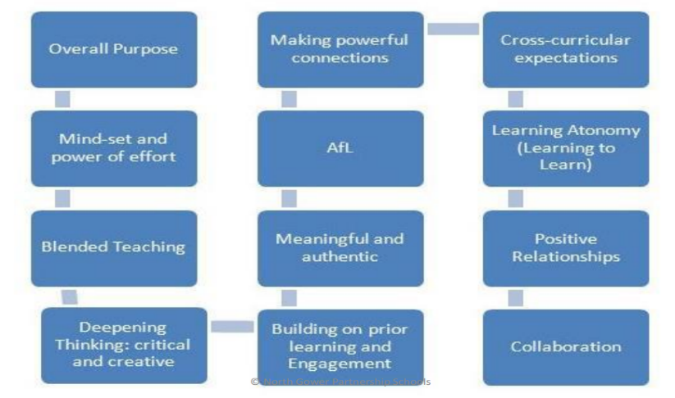

THE MATURITY CONTINUUM
Opportunities to develop independence and interdependence, throughout pupils’ time in
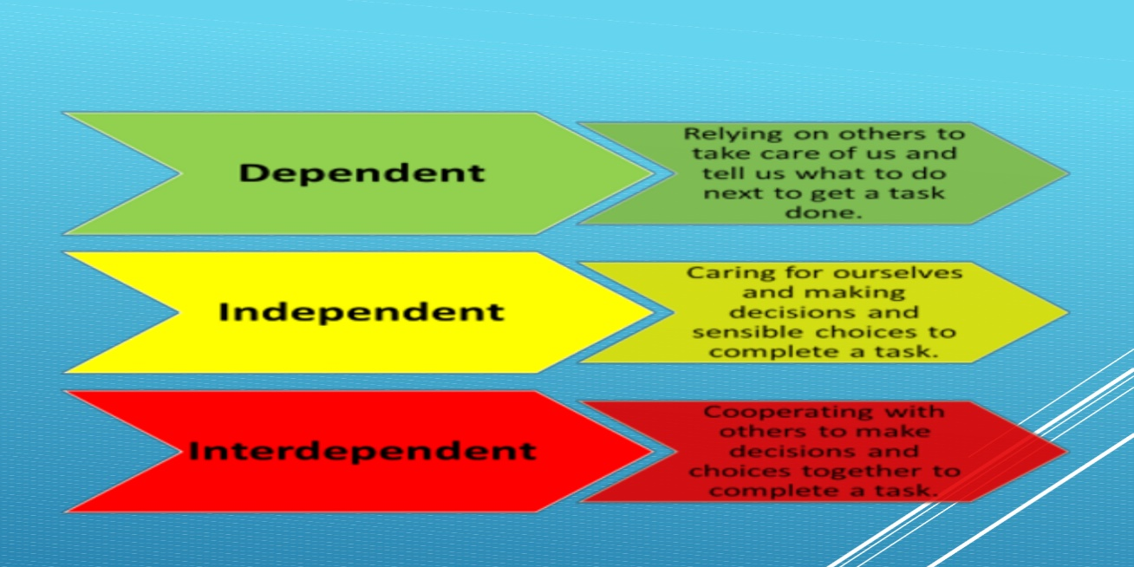
Parclewis is both visual and explicit. Staff consistently discuss this with the children through the maturity continuum, however, this must be recognised as a non-linear tool. As children are exposed to new skills they are dependent, and move towards interdependence as this new skill is understood and eventually applied. Knowledge, skills and experiences will be re-visited over time to enable mastery so that the pupil can intrinsically apply out of context

PLANNING AND PREPARING FOR LEARNING
Our curriculum places emphasis on equipping young people for life. It provides pupils with opportunities to learn, refine and apply new knowledge and skills in different situations. Every opportunity is used to develop the whole learner within real life contexts
Learners get a deep understanding of how to thrive in an increasingly digital world. We follow a digital competence framework developing digital skills across the curriculum, whilst preparing them for the opportunities and risks that an online world presents.

All teachers ensure that learners are ambitiously planned for, within a progression step relevant to their need. Each AoLE has a number of what matters statements, which ensure breadth, and coverage of the fundamental key concepts. The Curriculum for Wales set out clear descriptions for learning within each area of learning and experience. Teachers skilfully plan from these to ensure every pupil receives the support they need to make maximum progress.
Teachers use the PPA time effectively to plan, prepare and assess learning within their pods. This takes the form of the skills, knowledge and experiences that each child needs to be able to progress
As a guide to planning, the school has mapped out expectations for each year group. However, learners may be above or below the descriptions of learning within that particular progression step. A child’s progression step is not a 'best fit' model but a way to genuinely plan for an individual's progression in different areas of learning.

Year Group | Progression Step | Year Group | Progression Step
Nursery | Working towards PS1 | Year 3 | PS2
Reception | PS1 | Year 4 | Embedding PS2
Year 1 | Embedding PS1 | Year 5 | Working towards PS3
Year 2 | Working towards PS2 | Year 6 | PS3

APPROACHES TO TEACHING & LEARNING
In Parclewis Primary, staff deploy three overarching approaches to their teaching and learning preparation.
Spotlight Tasks (Teacher Directed) – Focused activities and experiences to develop skills across all AoLEs, pitched at the right level for individual learners.
Independent Quests (Teacher and Learner Directed) – Authentic, pupil influenced and relevant activities and experiences promoting collaboration and enabling pupils to apply their previously learnt skills at an appropriate level of challenge.
Choice & Challenge (Learner Directed) - Enables learners to have a range of opportunities to follow their needs and interests. These are open ended and integral skills based. Pupils are encouraged to follow their own lines of enquiry, developing self-efficacy and self-direction

BACKWARD PLANNING
Teachers plan and prepare learning with a clear understanding of pedagogy. Within any given lesson, adults consider their selection of methods in light of the purpose of learning. This involves the teachers’ blend of theoretical and practical knowledge, deciding on how best to promote effective learning. This approach is regarded as the “backwards model of planning” which moves away from the traditional model of planning from content.
“Its not what am I going to teach today, it’s what do my pupils need today!” Graham
Donaldson

SUPPORTING LEARNER INDEPENDENCE

Independence and interdependence doesn’t just happen as pupils get older. Our curriculum carefully considers how our teaching and learning can scaffold and promote their journey along the maturity curriculum. As the child moves away from being directed by the teacher, they will be encouraged to make choices in their learning (andragogy). At a more advanced stage of independence, learners will use the understanding of “what they need to learn” to help inform their choices of “how they are going to do it” (heutagogy). As new learning is introduced the child will need more teacher direction through the school’s spotlight approaches (pedagogy).
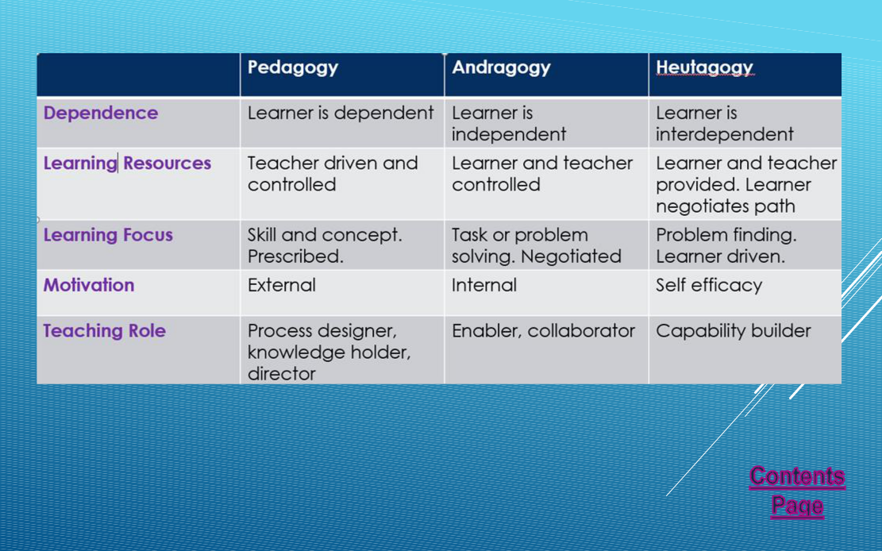
Striving for heutagogy (self efficacy and self direction) is undoubtedly the most difficult aspect of our curriculum design. Giving pupils “choice ” can lead to lack of “challenge”. This is why we have designed a style of teaching and learning called “Choice and Challenge.”
Through Choice & Challenge knowledge and skills can be developed through exploration (before targeted learning) or application (after targeted learning).
Learners are challenged through effective questioning from adults, peers or of themselves.
Given that the four purposes are underpinned by four integral skills, teachers use these to plan choice and challenge activities that will promote and support pupils along the maturity continuum. We encourage our pupils to develop these skills under four areas:-

- Be A Thinker

- Be Organised

- Be Creative

- Be Effective

ASSESSMENT

Our Assessment is underpinned by children’s rights principles. It is in line with the principle of using a range of assessment effectively to plan next steps for learners. It is fully inclusive, and considers the progress of all learners in a formative and summative assessment context.
We believe that effective assessment provides information to improve teaching and learning. We give our children regular feedback on their learning so that they understand what it is that they need to do better. This allows us to base our planning on a detailed knowledge of each pupil.
We give parents termly reports on their child’s progress so that teachers, children and parents are all working together to raise standards for all our children.
The aims and objectives of assessment in our school are:
- To enable our children to demonstrate what they know, understand and can do in their work;

- To help our children understand what they need to do next to improve their work;

- To allow teachers to plan work that accurately reflects the needs of each child;

- To provide regular information for parents that enable them to support their child’s learning;

- To provide the head teacher and governors with information that allows them to make judgements about the effectiveness of the school

FEEDBACK TO LEARNERS
In Parclewis, we believe that all children should be challenged in order to reach their potential. Feedback to pupils is clear, and staff ensure that pupils understand their next steps, and/or what they need to do to improve their work.
The school has a robust Feedback for Learning Policy providing all staff with a consistent, yet progressive approach to feedback to pupils. We mark pupils’ work and offer feedback in order to:
- show that we value their work, and encourage them to do the same;

- boost their self-esteem, through use of praise and encouragement;

- give them a clear general picture of how far they have come in their learning, and next steps

- offer them specific information on the extent to which they have met the lesson objective, and/or the individual targets set for them;

- promote self-assessment, whereby they recognise their difficulties and are encouraged to accept guidance from others;

- share expectations;

- gauge their understanding, and identify any misconceptions;

- provide a basis both for summative and for formative assessment;

- provide the ongoing assessment that should inform future lesson-planning

OUR LEARNING ENVIRONMENT
The learning environment is a means of adding greater depth and breadth to pupils’ learning as well as playing an important role in supporting the well-being of our learners. It raises self-esteem, celebrates what we do and encourages pride in the classroom and school

The school’s aims for the learning environment are:
- To motivate children by setting high standards to which they can aspire
- To support independence, interdependence and active learning
- To encourage collaboration
- To celebrate achievement
- To create a stimulating teaching and learning environment
- To encourage aesthetic awareness and a positive attitude to their own environments
- To arouse curiosity, pose questions and stimulate enquiry
- To increase children’s self-esteem and pride in their work
- To reflect and value different levels of achievement and cultural backgrounds
- To inform and inspire parents, carers, governors, teachers and visitors to the school.

EXPECTATIONS FOR LEARNING – THE TEACHER
- keep a consistent focus on the four purposes of the curriculum
- challenge all learners
- encourage sustained effort
- use a blend of pedagogical approaches to promote problem solving, creative and critical thinking
- build upon previous knowledge
- create authentic contexts for learning
- employ assessment for learning principles
- teach across all areas of learning and experiences
- reinforce cross-curricular responsibilities including literacy (Welsh and English), numeracy and digital competency
- provide opportunities for pupils to practice their skills in real life situations
- encourage pupils to take responsibility for their own learning
- support social and emotional development
- encourage independence and interdependence
- value the integral skills within their planning

EXPECTATIONS FOR LEARNERS
The pupils will...

- build from what they know

- ask questions about their learning

- value their own and others’ ideas

- learn from their mistakes

- make choices about their learning including when to use ICT

- have time to reflect on own and others’ work

- challenge themselves

- use a range of approaches to learning

- enjoy working together and on their own

Appendices
Appendix 1:

CURRICULUM CHECKLIST FORSTAFF – WELL-BEING
Provide opportunities for learners to talk about feelings and needs throughout the day, using the self-regulation tool when necessary

Encourage pupils to talk through their understanding of learning and actions and emotions

Make changes to the environment to suit the needs of the learners when necessary eg routines, displays, groupings, resources, self-regulation tool

Create an emotional environment which actively supports pupils to talk about their feelings and needs

Appendix 2:

CURRICULUM CHECKLIST FORSTAFF – EXTENDING LANGUAGE
Create an environment where learners are encouraged to lead conversations

Encourage effective interactions between learners by encouraging them to participate in purposeful conversations, questions and listening

Play/work alongside learners taking cues from them to develop imagination and creativity

Support language development by modelling appropriate grammar slightly above the child’s current level

Provide one to one feedback to every pupil at some point in the school day

Promote an inclusive environment to ensure every child feels included in all activities

Appendix 3:
CURRICULUM CHECKLIST FOR STAFF - CRITICAL THINKING
Activate prior knowledge through learners’ schemas and interests

Plan for a range of visitors, experiences and authentic contexts

Effectively utilise the local environment, Wales and the wider World to link learning to global contexts

Use objects, videos and resources effectively to inspire probing questions and problem raising

Provide visual learning opportunities by modelling metacognition and problem solving processes

Provide opportunities for pupils to plan their own learning

Provide opportunities for pupils to raise problems and solve them in a way that suits them

Encourage pupils to plan, undertake and reflect on their learning, linking to four purposes when appropriate

Evoke excitement through strategies such as treasure hunts, code breaking etc

Use factual and authentic materials to support learners’ knowledge and understanding of concepts

Engage learners with stories, songs and authentic materials to promote effective questioning, evaluation and prediction

Plan for a focus on each of nine reading behaviours in cross curricular contexts

Model scientific and problem solving approaches through talk and action

Use correct key and technical vocabulary and link these to learners’ own experiences

Encourage parents/carers to join in with activities and explorations
Appendix 4:
CURRICULUM CHECKLIST FOR STAFF – ASSESSMENT
Observe, provide learners with instant feedback, ask open ended questions, and scaffold where appropriate

Highlight strengths and difficulties and give clear instruction on next steps to success

Adhere to the Feedback for Learning Policy

Promote resilience at all opportunities e.g. persistence, concentration and completion of tasks

Encourage learners to provide one another with positive and supportive feedback

Share observations and assessments with parents/carers so that they can be supported at home

Appendix 5
CURRICULUM CHECKLIST FOR STAFF - INDEPENDENCE
Value learners’ views in planning their environment

Build upon the skills and knowledge learnt by providing opportunities for applications through Choice & Challenge Time

Plan from four purposes and integral skills to ensure readiness for real life

Plan flexibly and meets the needs and interests of the pupils through cross curricular approaches

Engage in activities to model and promote discussions

Provide opportunities, through Choice & Challenge, for pupils to follow their

Appendix 6

CHECKLISTS FOR STAFF- WORK DISPLAYED
Clear title – bilingual - with eye catching lettering

3D element to bring ‘learning to life’ e.g., books, artefacts linked to the topic

Work double mounted

Key and technical vocabulary and key questions

Good quality – well-presented and purposeful

Success Criteria – if appropriate

Differentiated, quality examples of work

Cross-curricular – Literacy, Numeracy, Digital

A variety of written texts styles (e.g. handwritten by student/adults, computer fonts, etc). This is because children will see a variety of texts in the world around them.

Appropriate four purposes, integral skills,

QR Codes

Quotes

